Chip Brommer

Professor Zhou

CSC 413 – Algorithms

19 March 2019

Project 2 – Binary Search Tree

For this report, I will use the required example as given in the assignment:



In-Order Tree Traversal:

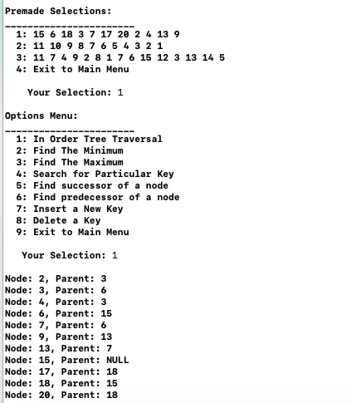

Search for a Particular Key:

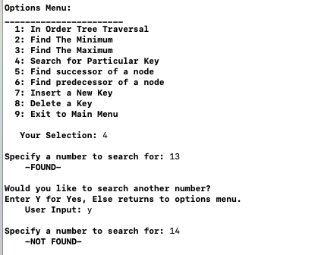

Find the Minimum and Maximum:

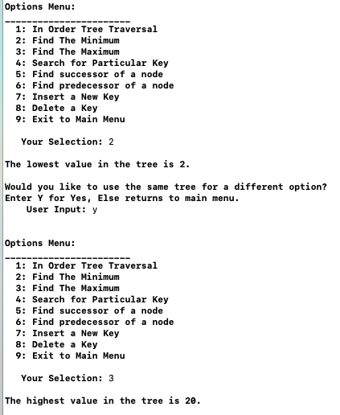

Find the Successor:

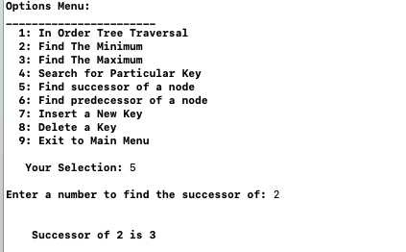

Find the Predecessor:

